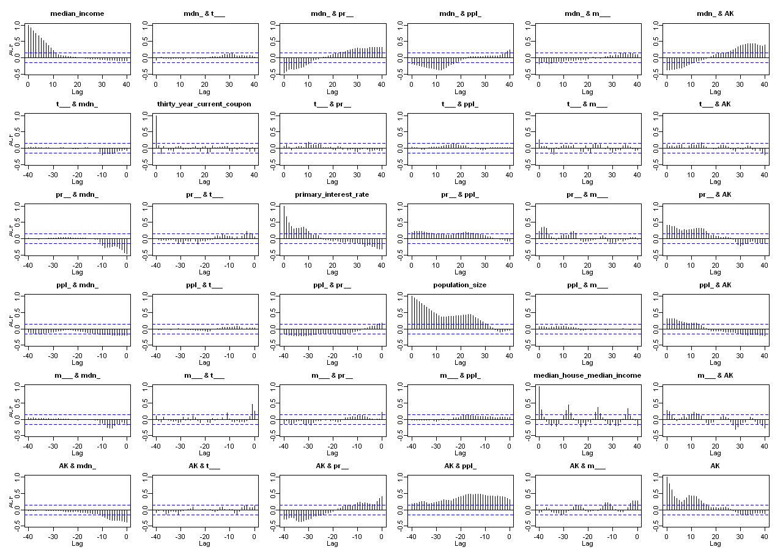
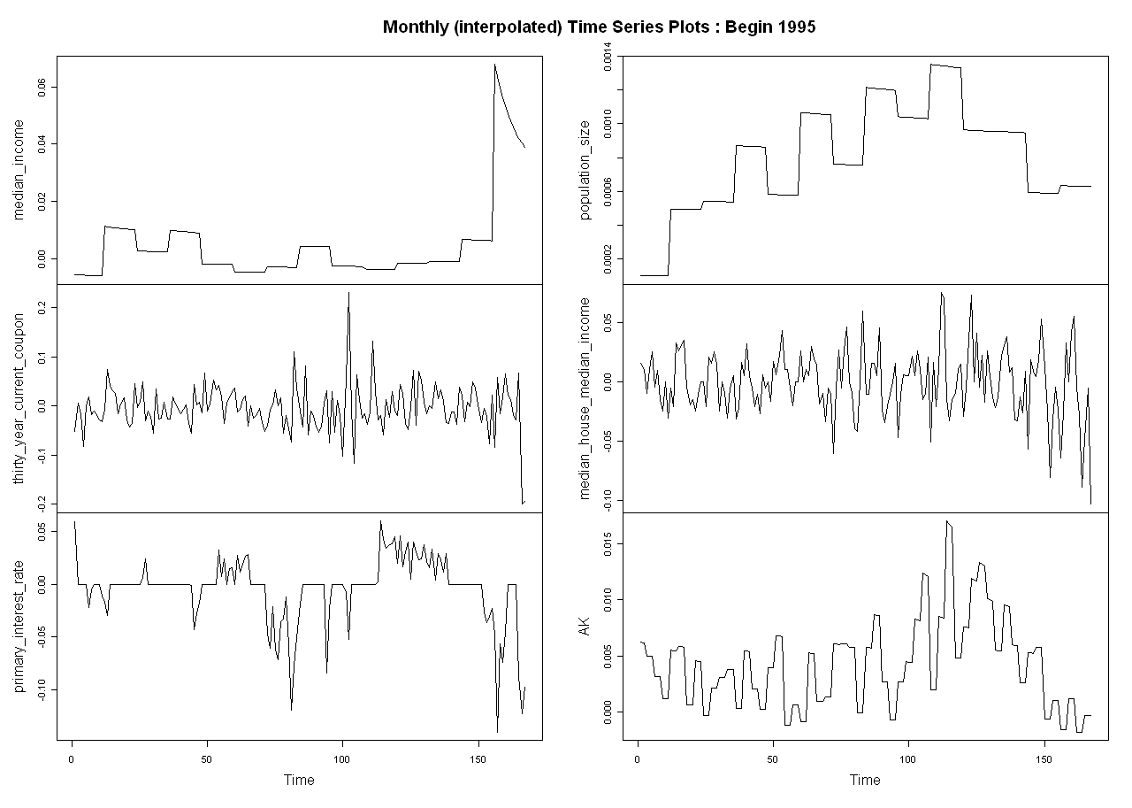
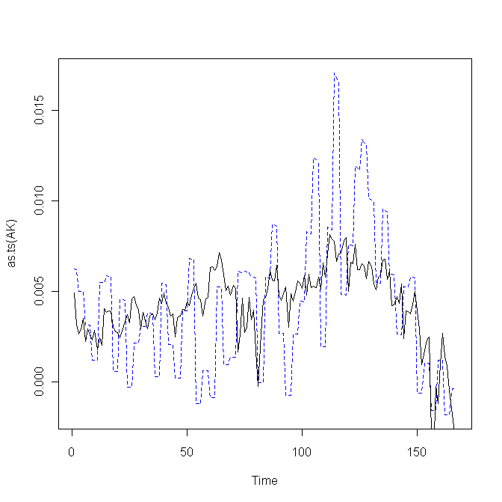

AK ~ median_income + thirty_year_current_coupon + primary_interest_rate +
population_size + median_house_median_income

Call:
lm(formula = form, data = combined_data_vector)

Residuals:
Min 1Q Median 3Q Max
-0.0072488 -0.0022961 0.0001095 0.0021071 0.0101571

Coefficients:
 | Coefficient | Std. Error | t-value | Pr(>|t|)
(Intercept) | 0.0023 | 0.00076 | 3.09 | 0.0023
median_income | -0.0552 | 0.021 | -2.57 | 0.0111
thirty_year_current_coupon | 0.0037 | 0.0058 | 0.65 | 0.5186
primary_interest_rate | 0.0308 | 0.0099 | 3.11 | 0.0022
population_size | 2.7971 | 0.87 | 3.23 | 0.0015
median_house_median_income | 0.0229 | 0.010 | 2.26 | 0.0249
*
---
Signif. codes: 0 ‘***’ 0.001 ‘**’ 0.01 ‘*’ 0.05 ‘.’ 0.1 ‘ ’ 1

Residual standard error: 0.003422 on 161 degrees of freedom
Multiple R-squared: 0.2904, Adjusted R-squared: 0.2683
F-statistic: 13.18 on 5 and 161 DF, p-value: 9.26e-11
